**Appendix 1 – USGS Patuxent Wildlife Research Center Bird Point Count Database**

The **Bird Point Count Database** [**http://www.pwrc.usgs.gov/point/**](http://www.pwrc.usgs.gov/point/) is an open submission archive of bird point counts that currently has data from 18 US states, Puerto Rico, and Alberta. The current site (Version 2) was established in 2006. Most data are from the eastern-half of the continental US; according to the site statistics. The site statistics appear to exaggerate the number of distinct sites and points accessible in the database, but it is evident that there are several thousand points scattered over greater than 100 sites. The surveys include breeding bird surveys, marsh bird surveys, and migratory bird surveys

The data are searchable by several geographic criteria, including state, physiogeographic region, or a biome-based bird conservation area. It is also searchable by bird species or year. On the Home Page, there is a brief description of point count methodology, and links to technical information on the methodology.

To access data, search or explore to find a geographic unit of interest (e.g. *New York* or *Lower Great Lakes Plain*). Selecting a desired geographic unit will list *Land Units* (e.g. *Montezuma NWR* ). Note that the listing can be sorted by *Land Unit*, *State*, type of site, and number of points or surveys.

Once a *Land Unit* has been selected, you will details about the land unit, including the years surveyed, the number of points surveyed, and the methodological details of the point counts (highlighted in brown box). Click ***Inventory*** to access a list of all species detected among the point counts for the *Land Unit*.

Click ***List of Points and Coordinates***to see a list of all points surveyed within the *Land Unit*  by a code name, along with a listing of other information including geocoordinates. Click on a selected point to access the summary table of species detected at that point, a description of the point, and its georeference. The georeference may be in decimal degrees or UTM. UTM georeferences be easily converted to decimal degrees (see Appendix 2).

There are several things to be aware of in using these data:

1. The summary table for a point count location is usually the cumulative presence-absence for all surveys that year. Sites have variable numbers of surveys, and species detected will increase with survey effort. Under ***Study Name***in the ***Land Unit Description***there is a list of the number of surveys per year. This information can also be accessed by clicking ***Learn More*** in the ***Point Count Point*** window.
2. The point count survey methodology, although generally standardized, varies across studies in important details including period during the year of the study (e.g. breeding season, migration), duration of a point count sample, and radial distance of samples. The methodological details can be found under ***Study Name***in the ***Land Unit Description***or accessed by clicking ***Learn More*** in the ***Point Count Point*** window.

The accuracy of the data is very sensitive to the skill and experience of the surveyor. I have detected some obvious errors likely due to misidentifications in some point count records.

**­­­­**

***An example of how to locate a point count data set*** (e.g. a point count location in Montezuma National Wildlife Refuge, New York State)***:***

1. From the Bird Count Database ***Home page***, under the option ***Explore*** select ***Search by state*** .
2. Select ***New York*** . Note that there are currently 9 land units and 1325 points in the Point Count Database for New York State.
3. Select ***Montezuma NWR*** . Note that there are currently 91 points and 246 surveys in the Point Count Database for the Montezuma National Wildlife Refuge.
4. Selecting ***NWR*** brings your to a page ***Land Unit Description*** *.* You will see listed information such as the number of points (91), the number of different studies (6), the date-span of the point counts (2007-2011).



1. 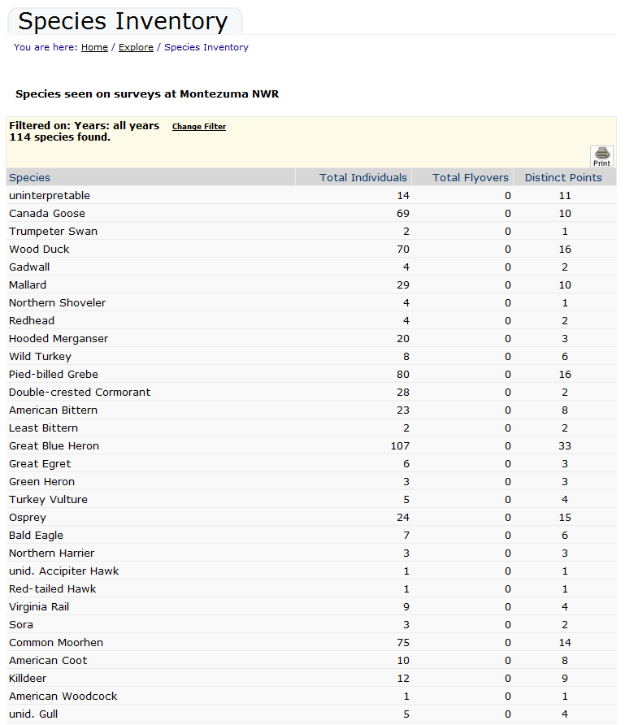From the ***Land Unit Description*** page, select ***Inventory*** to access a list of all species detected on any survey.
2. From the ***Land Unit Description*** page, select ***List of Points with Coordinates*** to access a list of all 91 points surveyed at Montezuma NWR.
3. Select the first listed point in the ***List of Points with Coordinates*** (AV1). You will see metadata on the point, including its location and time span, and a list of species detected during the point count.

